BLOGPOST - Founders Should Set Aside More Equity for Their Team & “Split the Pain” With Investors | Hunter Walk

Hunter Walk
99% Humble, 1% Brag
Founders Should Set Aside More Equity for Their Team & “Split the Pain” With Investors
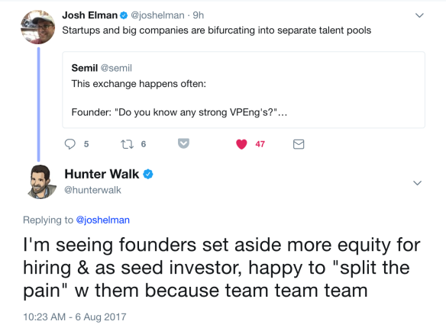

As you can see, Weekend VC Twitter gets pretty wild and crazy!!!! But employee option pool is important enough that I wanted to briefly expand upon my comment above.
Employee options pools, typically created at the point of financings, shouldn’t be treated as haggling over dilution, but rather a strategic resource that will help founders build the best team and, by extension, a more valuable company. Satya and I rarely see less than a 10% pool created at seed and Series A, but are increasingly engaging with founders about 12-15% pools, especially if you’re going to be hiring in-demand engineers (computer vision, AI) and/or (more typically post Series A), building out a senior executive team. While you should expect these sorts of hires to take below market cash comp versus what Google is paying them, this tradeoff needs to be replaced with equity upside.
Since Homebrew typically leads/co-leads seed rounds, we assist in helping founders design and manage their pool against their hiring forecast. No one wants to run out of equity pool midway between financings (and larger seed rounds these days usually means more hiring pre-A)! As a result we’re often amenable to a CEO suggesting, “hey, I’ve thought about it and I’d actually like to create a 12% pool instead of a 10% one. What if we split the pain [ie increase pre-money valuation slightly on our end and founders take slightly more dilution off their end]?” To me these types of conversations, when backed by a hiring plan, show real maturity and proactively valuing the construction of a high quality team.
Of course these conversations also work best when both the founders and investors have had a productive, give-and-take negotiation up to this point. If I’ve been stretched to my absolute limit on pricing and beaten up a bit, it’s less likely I can dig deeper for these other points, even if I think they’re overall constructive. There just may not be any more flesh to give! But in most cases it’s worth at least engaging with your investors around strategic pool creation rather than just termsheet defaults.

